

**Artificial Intelligence and Data Science Department.**

OS / Even Sem 2021-22 / Experiment 7.

**___________________________________________________**

YASH SARANG.

47 / D6AD.

EXPERIMENT - 7.

Semaphores.

**___________________________________________________**

**Aim:** Write a C program to implement the solution of Producer consumer problem through Semaphore.

**___________________________________________________**

**Theory:**

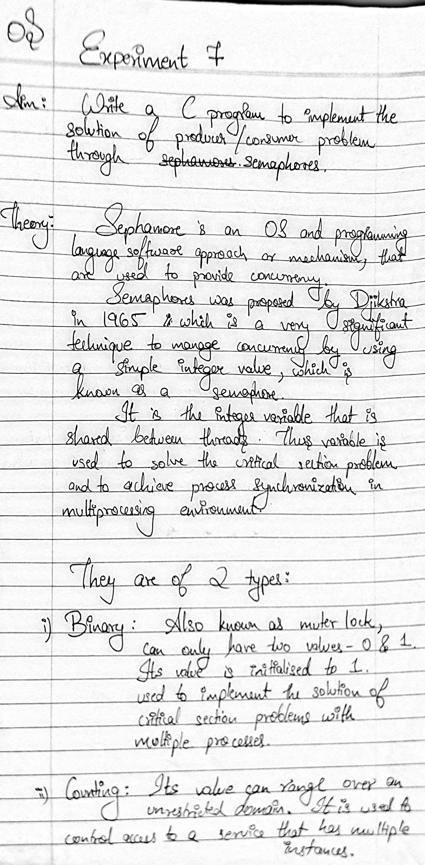

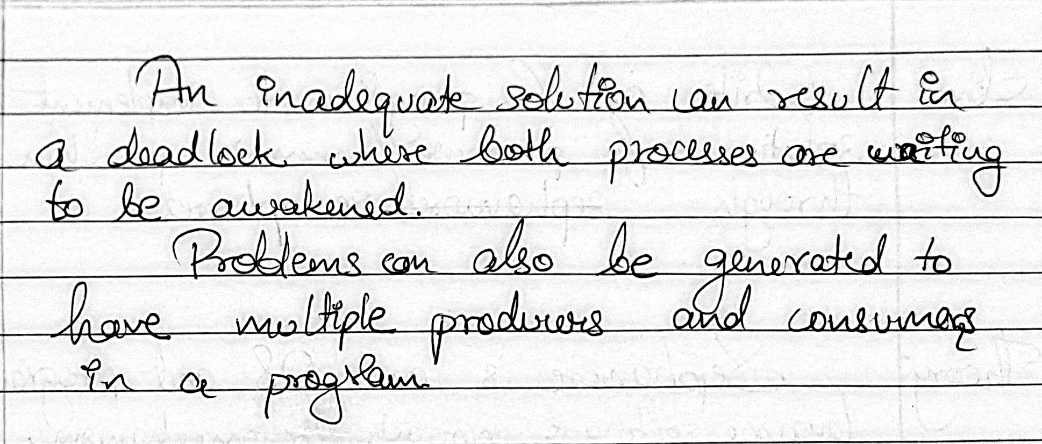

**___________________________________________________**

**Program Code:**

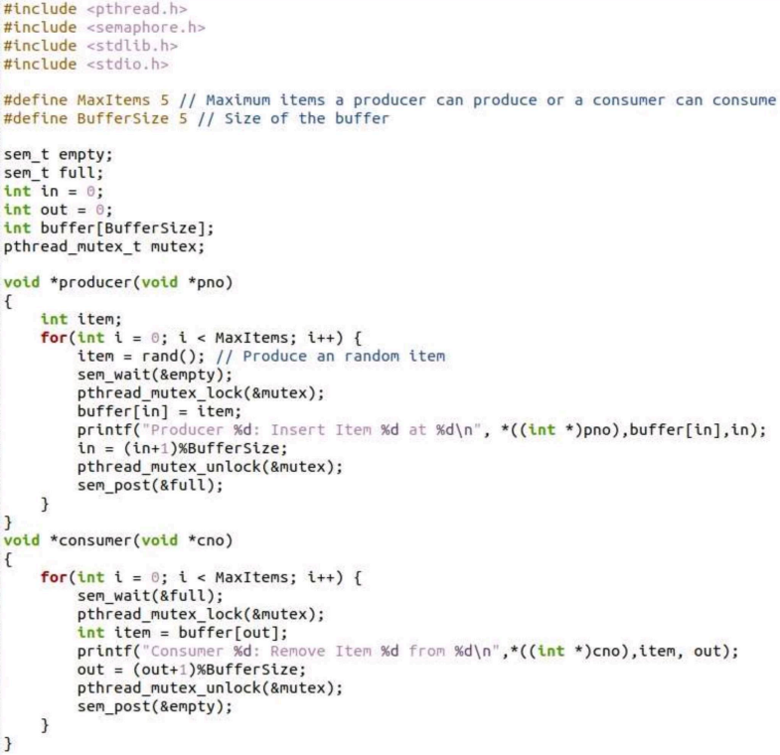

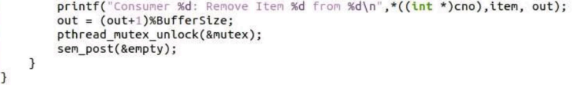

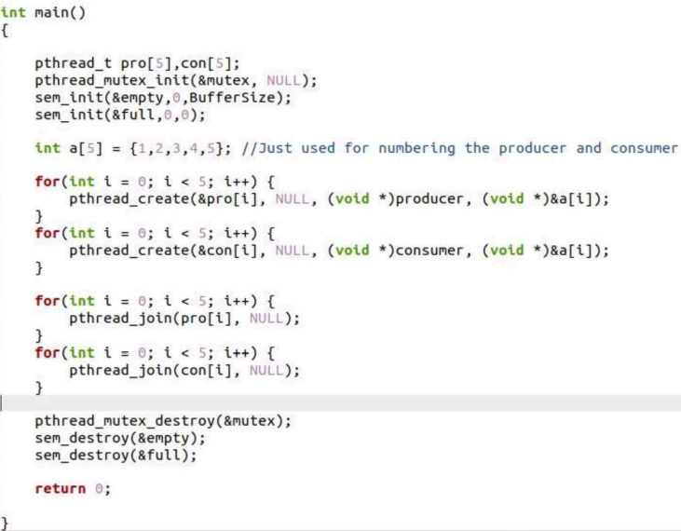

**___________________________________________________**

Conclusion:- 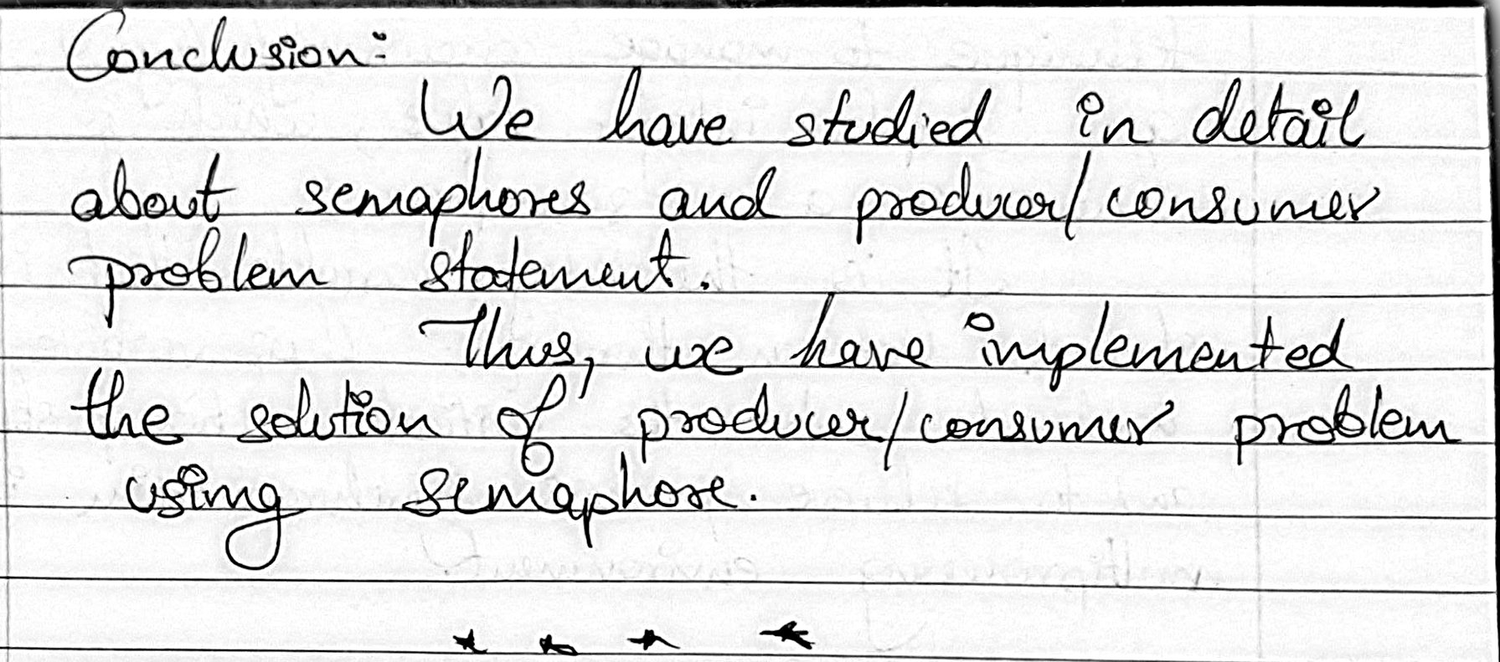

**___________________________________________________**

Output:-

